HUNTER VALLEY BANTAM CLUB INC
Membership Renewal
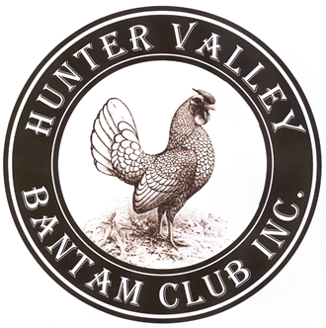 | Send with your show entries  Or to  Club Secretary  Tyson Mankelow  c/- 418 Lovedale Rd  Lovedale NSW 2325  Mobile 048 4785 109

Membership Fees are from 1st July 2022 to 30th June 2023.

Family Membership $15 Single Membership $10 Junior Membership $10
Please make cheques/ money orders payable to Hunter Valley Bantam Club Inc
Member’s Details Family Name (Print): _________________________________
First Name (Print): ______________________________________________
Address (Print): _________________________________________________________
_________________________________________________________
Postcode: __________________
Phone: _____________________________ Mobile: _______________________
Email (Print): _______________________________________________________________

Please complete the following
I occasionally have birds for sale ( YES / NO ) OR fertile eggs to sell ( YES / NO )
I give permission for my contact information to be given to enquirers ( YES / NO )

Breeds Kept – please list below
_______________________________________________________________________________________________________________________________________________________________________________________________________________________________________________________________________________________________________________________________________________________________________________________
Signature: _____________________________________ Date: ______________________

